CO-ORDINATION COMPOUNDS

RAKESH KUMAR

Lecturer in Chemistry

1. INTRODUCTION

2.2 Coordination Compounds

Co-ordination compounds play a vital role. The importance

can be realised that life would not have been possible without the existence of chlorophyll (Mg - complex) in plants and haemoglobin (Fe- complex) in the blood of human beings. The study of these compounds will enlarge our understanding of chemical bonding, physical properties such as magnetic properties of co-ordination compounds

Example

[Cu (NH ) ]SO

3 4 4

[Cu (NH ) ]2+ + SO2–

3 4

4

K [Fe(CN) ]

4

6

4K+ + [Fe (CN) ]4–

6

A coordination compound is a molecular compound that results from the combination of two or more simple molecular compounds and retains its identity in the solid as well as in dissolved state

2. MOLECULAR OR ADDITION COMPOUNDS

When solution containing two or more simple stable compounds in molecular proportions are allowed to evaporate, crystals of new substances called molecular or addition compounds are obtained.

Example

KCl + MgCl2 + 6H2O

KCl.MgCl 2 .6H2O

(Carnallite)

CuSO4 + 4 NH3

[Cu(NH 3 )4 ]SO4

(Tetrammine copper (II) sulphate)

Fe(CN)2 + 4KCN

K4[Fe(CN)6 ]

(Potassium ferrocyanide)

2.1 Types of Molecular compounds

3. COORDINATION COMPOUNDS

A Co-ordination compound consists of a ligand, central atom, complex ion, a cation or an anion. The complex ion is generally written in a square box and the ion (cation or anion) is written outside complex ion.

eg : [Co (NH3)6] Cl3

[Complex ion] anion

eg : K4 [Fe (CN)6]

cation [Complex ion]

General formula : Ax [MLn]/[MLn]By where : M is the central metal atom/ion

L is the ligand A is the cation B is the anion

Some Important Terms pertaining to Coordination Compounds

3.1 Coordination entity

* + 1. Double Salt



It is the central metal atom or ion which is bonded to a

definite number of ions or molecules which is fixed. For example, in [Co(NH ) ]Cl , a coordination entity, six ammonia

3 6 3

A double salt is a substance obtained by the combination of two different salts which crystallize together as a single substance but ionise as two distinct salts when dissolved in water. These salts lose their identity in solution i.e. when dissolved in water they give test of all the ions present in the salt. eg. Potash alum, Mohr’s salt

FeSO . (NH ) SO .6H O→ Fe2+ (aq)+ 6H O + 2NH + (aq)

4 4 2 4 2 2 4

molecules are surrounded by three chloride ions.

3.2 Central atom/ion

It is the central cation that is surrounded and coordinately bonded to one or more neutral molecules or negatively charged ions in a definite geometrical arrangement. For

example, in the complex [Co(NH ) ]Cl , Co3+ represents the

(Mohr’s salt) + 2 SO 2– (aq)

3 6 3

4

K SO . Al (SO ) . 24 H O → 2K+ (aq) + 2Al3+ (aq) +

2 4 2 4 3 2

central metal ion which is positively charged and is

coordinately bonded to six neutral NH3 molecules within the coordination sphere. The central metal/ion is also

(Potash alum) 4SO 3– (aq) + 24H O

4 2 referred to as Lewis acid.

+919814516618

The ions or molecules bound to the central atom/ion in the coordination entity are called ligands. These may be simple

ions such as Cl–, small molecules such as H O or NH , larger

2 3

molecules such as H NCH CH NH .

2 2 2 2

The number of atoms of the ligands that directly bound to the central metal atom or ion by co-ordinate bonds is known as the co-ordination number of the metal atom or ion. It is also equal to the secondary valency.

Complexes in which central atom is coordinated with only one kind of ligands are called homoleptic complexes, eg.

[Co(NH ) ]3+. Complexes in which central atom is coordinated with more than one kind of ligands are called

3 6

+hetroleptic complexes, eg. [Co (NH ) Cl ] .

2

3 4

4. NOMENCLATURE OF COORDINATION COMPOUNDS

The central metal atom or ion and the ligands that are directly attached to it are enclosed in a square bracket. This had been called coordination sphere or first sphere of attraction. It behaves as a single unit because the ligands present in the coordination sphere are held tightly by the metal ion.

A coordination polyhedron is the spatial arrangement of the ligand atoms that are directly attached to the central

atom/ion. For example, [Co(NH ) ]3+ is octahedral, [Ni(CO) ]

Following rules are adopted for naming a complex ion;

* + - 1. Cations are named before anions
      2. Oxidation state (O.S.) of the central metal ion is denoted by Roman numeral.

|  |  |  |  |
| --- | --- | --- | --- |
| Compound | Cation | O.S. | anion |
| CuCl | Copper | (I) | chloride |
| CuCl2 | Copper | (II) | chloride |
| FeCl2 | Iron | (II) | chloride |
| FeCl3 | Iron | (III) | chloride |

* + - 1. The names of ligands are given first followed by the name of the central metal ion.
      2. The names of ligands that are anions and ending with

‘ide’ are changed to ‘o’ ‘ite’ are changed to ‘ito’

3 6

is tetrahedral and [PtCl ]2 is square planar.

4

4 ‘ate’ are changed to ‘ato’

* + - 1. Many ligands that are molecules carry the unmodified name

It is defined as the charge that the central metal ion would carry if all the ligands are removed along with electron pairs. It is calculate as follows :

* + - 1. Positive groups end in – ium

hydrazinium.

+919814516618

RAKESH KUMAR

Lecturer in Chemistry

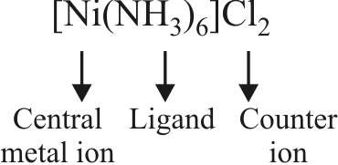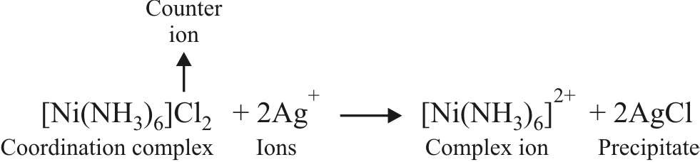

6

2

4

6

[Ag (CN) ]–

2

[Pt (NH3)2 Cl2]

[Ca (EDTA)]2–

K4 [Fe (CN)6]

Co-ordination numbers

Complex

3.5 Coordination sphere

Charge on complex ion = – 4 Let charge on Fe = x,

Now charge on cyanide ion (CN–) = –1

→ x + 6 × (–1) = – 4

→ x = + 2

Hence oxidation no of Fe = + 2 (or II)

6

6

4

K [Fe (CN) ] → 4 K+ + [Fe (CN) ]4–

K4 [Fe (CN)6]

Example

3.3 Ligands

3.4 Co-ordination Number (C.N)

3.6 Co-ordination Polyhedron

3.7 Oxidation Number of Central Metal Atom

3.8 Homoleptic and Hetroleptic Complexes

4.1 Nomenclature

* + - 1. When there are several ligands of the same kind, we normally use the prefixes di, tri, tetra, penta and hexa to show the number of ligands of that type. An exception occurs when the name of the ligands includes a number, for example as in ethylenediamine (en). To avoid confusion in such cases, bis, tris and tetrakis are used instead of di, tri and tetra, and the name of the ligand is placed in brackets.

e.g. bis (ethylenediamine)

* + - 1. If anion is a complex, then metal ends with ‘ate’

[Ni(CN)4 ]2– : tetracyanonickelate (II) ion lead – plumbate

gold – aurate

zinc – zincate

tin – stannate

silver – argentate

cobalt – cobaltate

iron – ferrate

aluminium – aluminate

manganese – manganate

copper – cuprate

chromium – chromate

platinum – platinate

1. If the complex contains two or more metal atoms, it is termed polynuclear. The bridging ligands which link the two metal atoms together are indicated by the prefix µ –
2. Ambidentate ligands may be attached through different atoms

M → NO2 (NO2 joined to metal M through N; it is nitrito-N)

M → ONO (NO2 joined to metal M through

O; it is nitrito-O)

Similarly, the SCN group may bond M – SCN (thiocyanato) or M – NCS (isothiocyanato).

1. When writing (not naming) the formula of the complex :
   * Complex ion should be enclosed by square brackets and
   * Ligands are placed after metal in the alphabetical order but first negative ligands, then neutral, then positive.

# 5. WERNER’S THEORY

Werner explained the nature of bonding in complexes and he concluded that in complexes the metal shows two different types of valency.

The primary valency is equal to the oxidation state of the central metal atom or ion. These are non-directional.

The number of ligand atoms co-ordinated to the central metal atom is called secondary valency. These are directional and so a complex ion has a particular shape.

+919814516618

RAKESH KUMAR

Lecturer in Chemistry

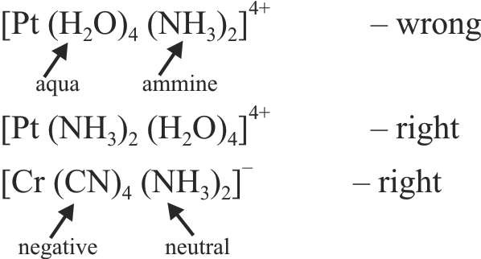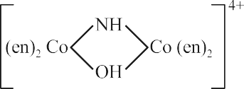

Sol. (a) Hexaammineiron (III) Chloride

1. Pentaamminechloridocobalt (III) ion
2. Tetraamminesulphatocobalt (III) nitrate
3. Tetrapyridineplatinum (II) tetrachloridoplatinate (II)
4. Tris (ethylenediamine) chromium (III) chloride
5. Tetrakis (ethylenediamine)–µ-hydroxo-µ-imidodicobalt

(III) ion.

(f)

3 5

[CoSO4 (NH3)4] NO3 [Pt (Py)4] [PtCl4]

[Cr (en)3] Cl3

[CoCl(NH ) ]2+

[Fe(NH3)6]Cl3

(a)

(b)

(c)

(d)

(e)

EXAMPLE : Write the name of the following compounds ?

Sol. K4 [Fe (CN)6] : Primary valency is 2.

[Cu (NH3)4] SO4 : Primary valency is 2.

3 6

& [Co (NH ) ]3+ ?

EXAMPLE : What are the primary valency of [Co (NH3)6] Cl3

5.1 Primary Valency

5.2 Secondary Valency

be tetrahedral or square planar. This postulate predicted the existence of different types of isomerism in coordination compounds.

RAKESH KUMAR

Lecturer in Chemistry

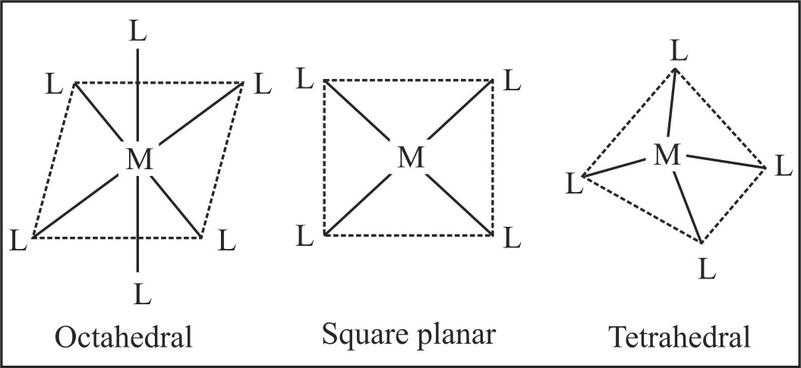

An anion present in co-ordination and ionization sphere is shown by

Every element tends to satisfy both its primary and secondary valencies. A negative ion when present in the coordination sphere shows a dual behaviour. It may satisfy

both primary and secondary valencies.

EXAMPLE : What are the secondary valency of

[Co (NH3)6] Cl3 & K4 [Fe (CN)6] ?

Sol. In [Co (NH3)6] Cl3 the secondary valency is 6.

K4 [Fe (CN)6] : six ligands are coordinated to Fe. Hence secondary valency is 6.

The primary valency is satisfied by ions attached to the complex ions. It is shown by dotted lines. Primary valency is also known as ionisable valency.

The secondary valency is satisfied by the ligands, they

are non ionisable and are shown by a solid line [Co (NH3)6] Cl3 can be represented as

– – –

X = Cl , Br , I

6

3 6

2–

4+

[Pt(NH ) ] ; [PtCl ]

6

6

2–

[NiX4]

2+

[Cu(NH3)4]

3–

2–

[Fe(CN) ] ; [Fe(F )]

4

4

2 6

3 6

2–

2–

[CuX ] ;[ZnCl ]

2+

[Ni(NH3)4]

3+

3+

[Co(NH ) ] ; [Cr(H O) ]

[Ni(CO)4]

4

2–

[Ni(CN) ]

3+

[Cr(CH3)6]

(C.N. = 4)

(C.N = 4)

(C.N = 6)

Square planar Tetrahedral

EXAMPLES:

Octahedral

C.N.

Divalent

C.N.

Univalent

Ag+ Au+ Ti+ Cu+

6

6

4

+

Os3+

Ir3+ Au3+

Co3 6

6

6

C.N.

Tetravalent

Pt4+ Pd4+

C.N.

6

6

6

Trivalent

Sc3+ Cr3+ Fe3+

Familiar C.N.’s of some common metal ions.

|  |  |  |
| --- | --- | --- |
| 2 | V2+ | 6 |
| 2, 4 | Fe2+ | 6 |
| 2 | Co2+ | 4, 6 |
| 2, 4 | Ni2+ | 4,6 |
|  | Cu2+ | 4, 6 |
|  | Zn2+ | 4 |
|  | Pd2+ | 4 |
|  | Pt2+ | 4 |
|  | Ag2+ | 4 |

The ligand which satisfy the secondary valencies are directed toward fixed positions in space. The geometry of the complex ion depends on the coordination number. If the metal has coodination number 6, the complex is octahedral,

i.e. six positions around the metal are occupied by six donor

atoms of the ligands octahedrally. On the other hand, if the coordination number is 4, the geometry of the complex may

+919814516618

6. EFFECTIVE ATOMIC NUMBER (EAN)

Sidgwick proposed effective atomic number abbreviated as EAN, which is defined as the resultant number of electrons with the metal atom or ion after gaining electrons from the donor atoms of the ligands. The effective atomic number (EAN) generally coincides with the atomic number of next

inert gas in some cases. EAN is calculated by the following relation :

EAN = Atomic number of the metal – number of electrons lost in ion formation + number of electrons gained from the donor atoms of the ligands. (2 × CN)

The EAN values of various metals in their respective complexes are tabulated below :



RAKESH KUMAR

Lecturer in Chemistry

+919814516618

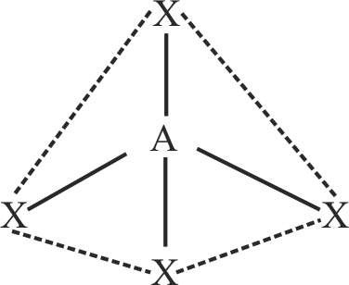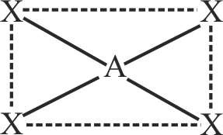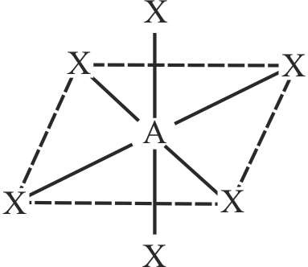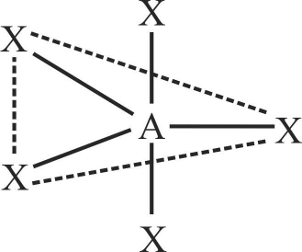

2

sp

Linear

X — A — X

4

sp3

Tetrahedron

4

dsp2

Square planar

5

sp3d

Trigonal

or dsp3

bipyramid

6

d2sp3

Octahedral

or sp3d2

orbitals incomplete. Valence bond takes into account the hybridisation of orbitals since penultimate d-orbitals are near in energy to s and p-orbitals of the outer most shell, various kinds of hybridization is possible.

VBT makes the following assumption

1. A number of empty orbitals are available on the central metal ion which can accomodate electrons donated by the ligands. The number of empty d-orbitals is equal to the coordination number of the metal ion for the particular complex.
2. The metal orbitals and ligand orbitals overlap to form strong bonds. Greater the extent of overlapping, more is the stability of the complex. Different orbitals (s, p or d) hydridize to give a set of equivalent hybridized orbital which take part in bonding with the ligands.
3. Each ligand donates a pair of electrons to the central metal ion/atom.
4. The non-bonding metal electrons present in the inner orbitals do not take part in chemical bonding.
5. If the complex contains unpaired electrons, the complex is paramagnetic. If it does not contain unpaired electron, the complex is diamagnetic in nature.
6. Under the influence of strong ligand (CN, CO) the electrons can be forced to pair up against the Hund’s rule of multiplicity.

|  |  |  |  |  |
| --- | --- | --- | --- | --- |
| Complex | Metal (Oxid. state) | At. No. of metal | Coordination number | Effective atomic number |
| K4 [Fe (CN)6] | + 2 | 26 | 6 | (26 – 2) + (6 × 2) = 36 [Kr] |
| [Cu (NH3)4] SO4 | + 2 | 29 | 4 | (29 – 2) + ( 4 × 2) = 35 |
| [Co (NH3)6] Cl3 | + 3 | 27 | 6 | (27 – 3) + (6 × 2) = 36 [Kr] |
| Ni (CO)4 | 0 | 28 | 4 | (28 – 0) + (4 × 2) = 36 [Kr] |
| K2 [Ni(CN)4] | + 2 | 28 | 4 | (28 – 2) + (4 × 2) = 34. |
| 7. VALENCE BOND THEORY COMMON TYPES OFHYBRIDISATION  The bonding in coordination compounds can be explained  by Valence Bond Theory (VBT) since majority of the Coordination Hybridi- Shape Geometry  complexes formed by the transition metals have their d- Number zation | | | | |

CO-ORDINATION COMPOUNDS

The lobes of the eg orbitals (dx2 –y2 and dz2 )

RAKESH KUMAR

Lecturer in Chemistry

NOTE:

In d2sp3 hybridisation, the inner d-orbitals (3d orbital) has been used for bonding, such complexes are called inner orbital complexes or low spin complexes.

In sp3d2 hybridisation the outer d-orbitals (4d orbital) has been used for bonding, such complex are called outer orbital complexes or high spin complexes.

The magnetic moment is given by n(n + 2) BM where n is the number of unpaired electrons.

point along

the x, y and z axes. the lobes of the t2g orbitals (dxy , dxz and dyz ) point in between the axes. The approach of six ligands along the x, y, z, –x, – y and – z directions will

increase the energy of the dx2 –y2

and dz2

orbitals (which

point along the axes) much more than it increases the energy

of the dxy, dxz and dyz orbitals (which point between the

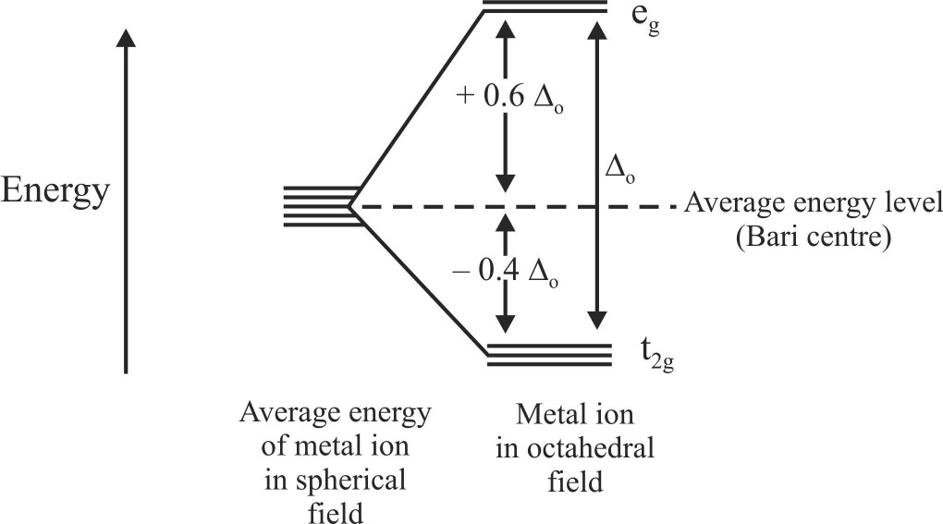axes). Thus under the influence of an octahedral ligand field the d orbitals split into two groups of different energies.

7.1 Limitations of VBT

1. The change in the properties of the ligands and the metal ions could not be explained.
2. The valence bond theory does not explain why certain complexes are more labile than other.
3. The VBT does not provide satisfactory explanation for the existence of inner orbital and outer orbital complexes.
4. The VBT could not explain the colour of complexes

8. CRYSTAL FIELD THEORY

The Crystal Field Theory is more widely accepted than the valence bond theory. It assumes that the attraction between the central metal and the ligands in a complex is purely electrostatic. In the crystal field the following assumptions are made.

1. Ligands are treated as point charges.
2. There is no interaction between metal orbitals and ligand orbitals.
3. The d orbitals on the metal all have the same energy (that is degenerate) in the free atom. However, when a complex is formed the ligands destroy the degeneracy of these orbitals,

i.e. the orbitals now have different energies.

Ligands which cause only a small degree of crystal field splitting are termed weak field ligands. Ligands which cause a large splitting are called strong field ligands. The common ligands can be arranged in ascending order of crystal field splitting O.

Spectrochemical Series

I–<Br–<S2–<Cl– < NO– <F– <OH– <EtOH<oxalate<H O

3

2

(weak field ligands)

< EDTA < (NH3 = pyridine) < ethylenediamine < dipyridyl

< o- phenanthroline < NO– < CN– < CO

2

(strong field ligands)

A pattern of increasing o donation is followed :

Halide donors < O donors < N donors < C donors

The total crystal field stabilization energy is given by CFSE(octahedral) = –0.4n(t ) + 0.6n(e )

2g g

2g

g

where

+919814516618

8.1 Octahedral complexes

n(t ) and

n(e ) are the number of electrons

In an octahedral complex, the metal is at the centre of the octahedron, and the ligands are at the six corners. The directions x, y and z point to three adjacent corners of the octahedron as shown.

occupying the t2g and eg orbitals respectively. The CFSE is zero for ions with d0 and d10 configurations in both strong and weak ligand field. The CFSE is also zero for d5 configurations in a weak field.

EFFECTS OFCRYSTALFIELD SPLITTING

CFSE and electronic arrangements in octahedral complexes

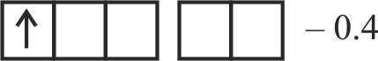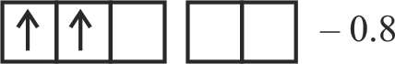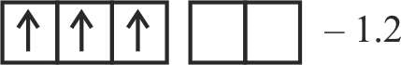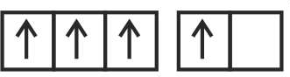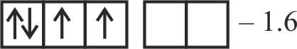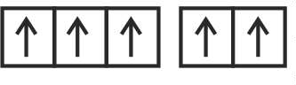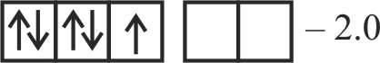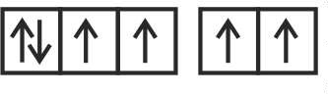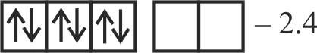

Number Arrangement in weak ligand field Arrangement in strong ligand field of d

electrons t2g eg CFSE Spin only t2g eg CFSE Spin only

**O**o magnetic moment **O**o magnetic moment

|  |  |
| --- | --- |
| **µ**s (D) | **µ**s (D) |
| d1 1.73 | 1.73 |
| d2 2.83 | 2.83 |
| d3 3.87 | 3.87 |
| d4 – 0.6 4.90 | 2.83 |
| d5 – 0.0 5.92 | 1.73 |
| d 6 – 0.4 4.90 | 0.00 |

d7 d8 d9

d10

– 0.8

– 1.2

– 0.6

0.0

3.87

2.83

1.73

0.00

– 1.8

– 1.2

– 0.6

0.0

1.73

2.83

1.73

0.00

8.2 Tetrahedral Complexes

A regular tetrahedron is related to a cube. One atom is at the centre of the cube, and four of the eight corners of the cube are occupied by ligands as shown.

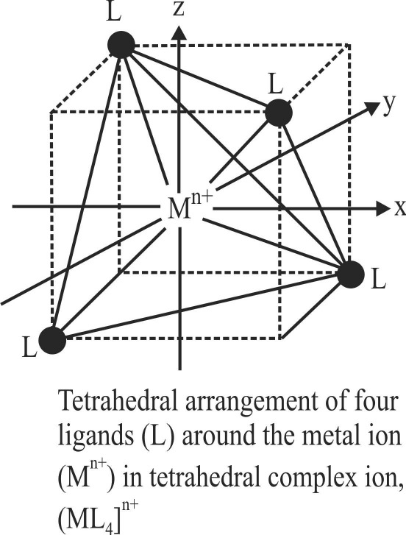

The directions x, y and z point to the centres of the faces of the cube. The e orbitals point along x, y and z axes (that is to the centres of the faces). The t2 orbitals point between x, y

and z axes (that is towards the centres of the edges of the

cube). The direction of approach of the ligands does not coincide exactly with either the e or the t2 orbitals.

Thus the t2 orbitals are nearer to the direction of the ligands than the e orbitals. The approach of the ligands raises the

energy of both sets of orbitals. The energy of the t2g orbitals is raised most because they are closest to the ligands. The

crystal field splitting is the opposite way round to that in octahedral complexes

The t2 orbitals are 0.4Ot above weighted average energy of the two groups (the Bari centre) and the e orbitals are 0.6Ot below the average.

The magnitude of the crystal field splitting Ot in tetrahedral complexes is considerably less than in octahedral fields. There are two reasons for this :

* 1. There are only four ligands instead of six, so the ligand field is only two third the size ; hence the ligand field splitting is also two third the size.
  2. The direction of the orbitals does not coincide with the direction of the ligands. This reduces the crystal field splitting by roughly a further two third.

+919814516618

RAKESH KUMAR

Lecturer in Chemistry

Thus the tetrahedral crystal field splitting Ot is roughly 2/3 × 2/3 = 4/9 of the octahedral crystal field splitting Oo.

# 9. ORGANOMETALLIC COMPOUNDS

Compounds that contain at least one carbon–metal bond are called organometallic compounds.

Grignard reagent, RMgX is a familiar example of organometallic compounds where R is an alkyl group. Diethyl zinc [Zn(C2H5)2], lead tetraethyl [Pb(C2H5)4], ferrocene

[Fe(C5H5)2], dibenzene chromium [Cr(C6H6)2], metal

carbonyls are other examples of organometallic compounds. Organometallic compounds may be classified in three classes :

1. Sigma (o) bonded complexes.
2. Pi (n) bonded complexes,
3. Complexes containing both o– and n–bonding characteristics.
   1. Sigma bonded complexes

In these complexes, the metal atom and carbon atom of the ligand are joined together with a sigma bond, i.e., the ligand contributes one electron and is, therefore, called one electron donor. Examples are :

1. Grignard reagent, R–Mg–X where R is an alkyl or aryl group and X is halogen.
2. Zinc compounds of the formula R2Zn such as (C2H5)2Zn. This was first isolated by Frankland in 1849. Other similar

compounds are (CH3)4Sn, (C2H5)4Pb, Al2(CH3)6, Al2(C2H5)6 and Pb(CH3)4, etc.

* 1. **n**–bonded organometallic compounds

These are the compounds of metals with alkenes, alkynes, benzene and other ring compounds. In these complexes, the metal and ligand form a bond that involves the n electrons of the ligand. Three common examples are Zeise’s salt, ferrocene and dibenzene chromium. These are shown here :

The number of carbon atoms bound to the metal in these compounds is indicated by the Greek letter ‘y’ (eta) with a number. The prefixes y2, y5 and y6 indicate that 2, 5 and 6 carbon atoms are bound to the metal in the compound.

* 1. **o**– and **n**–bonded organometallic compounds

Metal carbonyls, compounds formed between metal and carbon monoxide belong to this class. These compounds posses both o– and n– bonding. The oxidation state of metal atoms in these compounds is zero. Carbonyls may be monomeric, bridged or polynuclear.

In a metal carbonyl, the metal–carbon bond possesses both the o– and n–character. A o–bond between metal and carbon atom is formed when a vacant hybrid orbitals of the metal atom overlaps with an orbital on C atom of carbon monoxide containing a lone pair of electrons.

– +

Formation of n–bond is caused when a filled orbital of the metal atom overlaps with a vacant antibonding n* orbital of C atom of carbon monoxide. This overlap is also called back donation of electrons by metal atom to carbon. It has been shown below :

The n–overlap is perpendicular to the nodal plane of o–bond. In olefinic complexes, the bonding n–orbital electrons are donated to the empty orbital of the metal atom and at the same time back bonding occurs from filled orbital of the metal atom to the antibonding n–orbital of the olefin.

+919814516618

RAKESH KUMAR

Lecturer in Chemistry

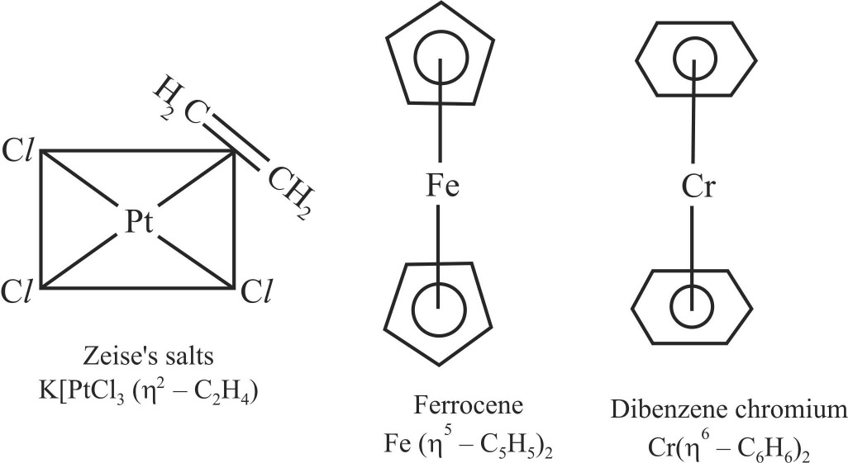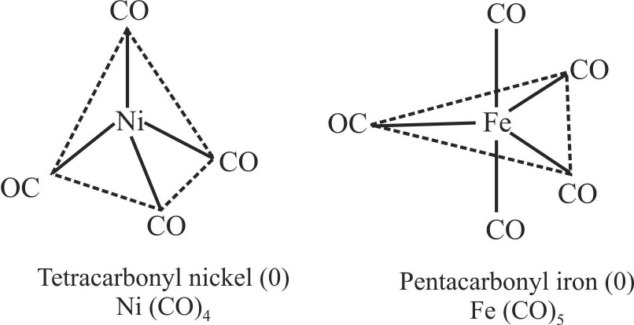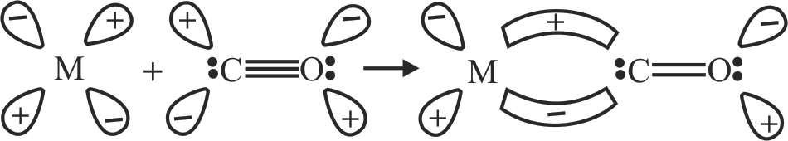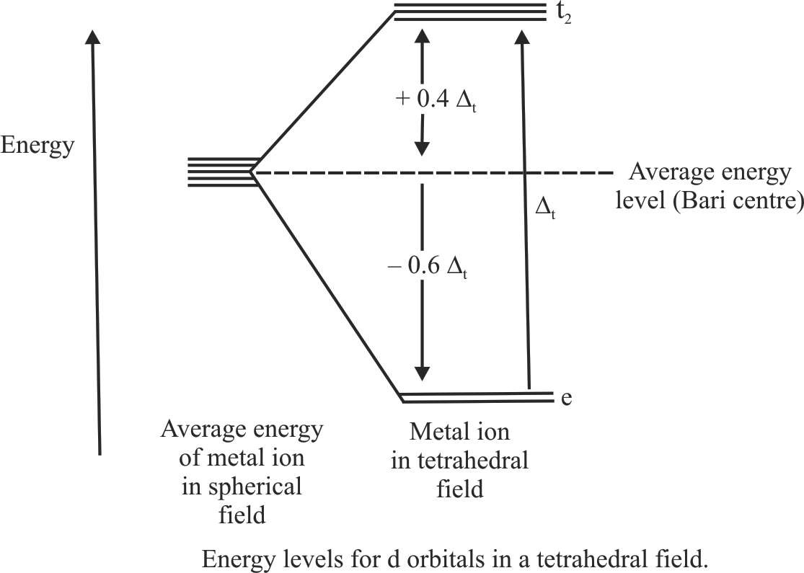

# 10. ISOMERISM

The compounds having same molecular formula but different structural formula are called isomers.

* + 1. Linkage Isomerism : This type of isomerism occurs in complex compounds which contain ambidentate ligands

like NO– , SCN– , CN– , S O2– and CO.

2 2 3

For example, [Co(NH3)5NO2] Cl2 and [Co(NH3)5ONO] Cl2

are linkage isomers as NO– is linked through N or through

2

O.

* + 1. Ligand Isomerism : Some ligands themselves are capable of existing as isomers, e.g., diamino propane can exist both as 1, 2-diamino propane (pn) and 1, 3-diamino propane, also called trimethylene diamine (tn).
    2. Ionisation Isomerism : This type of isomerism arises when the coordination compounds give different ions in solution. For example, there are two isomers of the formula Co (NH3)5 BrSO4.

When these ligands (i.e., pn and tn) are associated into complexes the complexes are isomers of each other. One example of isomeric complexes having this ligand is :

2

2

2

[Co(NH3 )5 Br] SO4

[Co(NH

3 )5

Br]2+ + SO2–

[Co(pn)2

Cl ]+ and [Co(tn)

Cl ]+ ions.

(Violet)

4

Pentaamminebromido

–cobalt (III) ion

10.1.6 Coordination position isomerism : This type of isomerism is exhibited by polynuclear complexes by

This isomer gives a white percipitate of BaSO4 with BaCl2

solution.

changing the position of ligands with respect to different metal atoms present in the complex. For example,

[Co(NH3 )5SO4 ]Br

(Red)

[Co(NH3 )5 SO 4 ]+ + Br–

Pentaamminesulphato

–cobalt (III) ion

Above isomer gives light yellow precipitate withAgNO3 solution.

* + 1. Hydrate Isomerism : This type of isomerism arises when different number of water molecules are present inside and outside the coordination sphere. This isomerism is best illustrated by the three isomers that have the formula CrCl3.6H2O.

[Cr(H2O)6]Cl3 , [Cr(H2O)5Cl]Cl2.H2O, and [Cr(H2O)4Cl2]

Cl.2H2O are its Hydrate Isomers.

* + 1. Cordination Isomerism : This type of isomerism is observed in the coordination compounds having both cationic and anionic complex ions. The ligands are interchanged in both the cationic and anionic ions to form isomers. An examples is :

and

Stereo isomerism is exhibited by those compounds which have the same position of atoms or groups but these atoms or groups have different arrangement around the central atom.

* + 1. Geometrical Isomerism

The complex compounds which have the same ligands in the co-ordination sphere but the relative position of the

[Pt(NH3 )4 ] [CuCl4 ]

RAKESH KUMAR

Lecturer in Chemistry

+919814516618

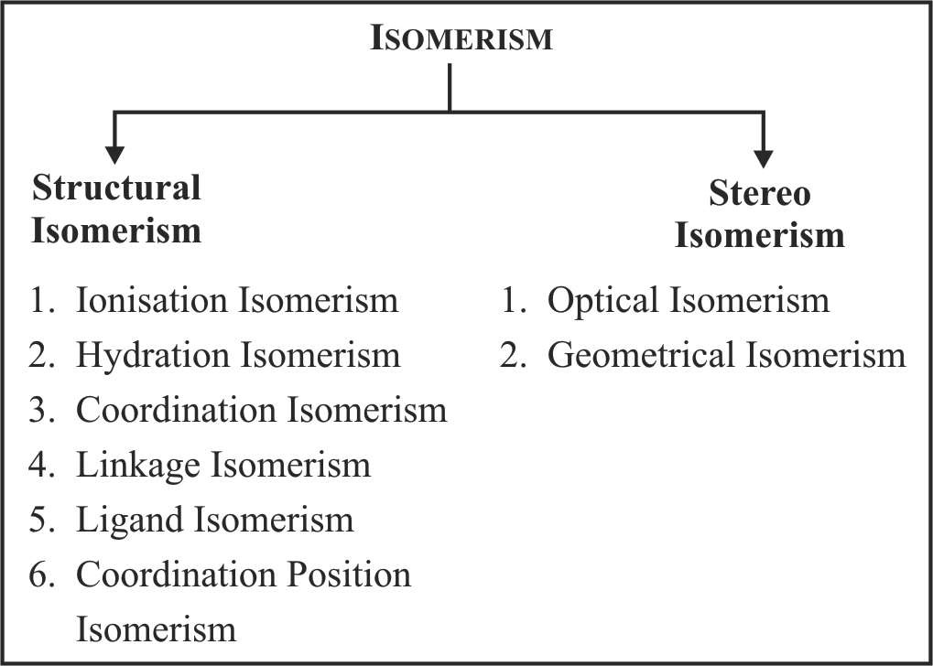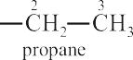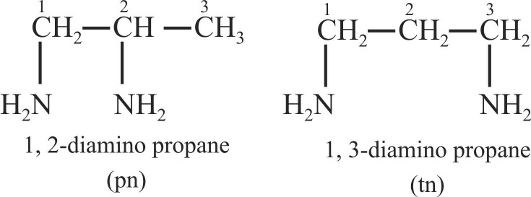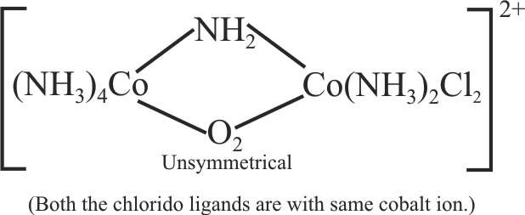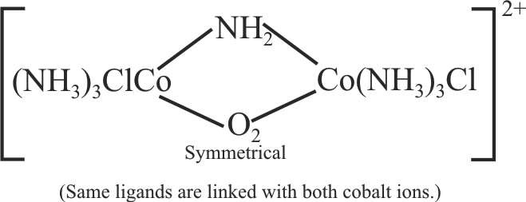

10.1 Structural Isomerism

10.2 Stereo Isomerism

Tetraammineplatinum (II) tetrachloridocuprate (II)

and

[Cu(NH3 )4 ] [PtCl4 ]

Tetraamminecopper (II) tetrachloridoplatinate (II)

ligands around the central metal atom is different are called

geometrical isomers and the phenomenon is called geometrical isomerism.

* + - 1. Geometrical Isomerismin square planarcomplexes

A square planar complexe having similar ligands at adjacent positions (90º a part) is called cis - isomer while a square planar complex having two similar ligands at opposite positions (180º a part) is called trans-isomer.

1. Ma2b2

3. Mabcd

Example - 1

Draw the geometrical isomers of [PtCl2(NH3)2]

Sol.

Example - 3

Draw the geometrical isomers of [PtClBrpy (NH3)]

Sol.

2. Ma2bc

4. M (AB)2

Example - 4

Draw the geometrical isomers of [Pt(gly)2]

Sol.

RAKESH KUMAR

Lecturer in Chemistry

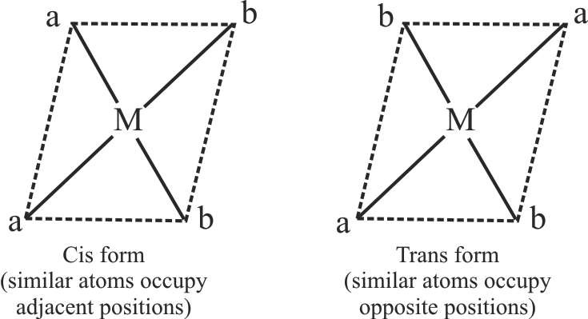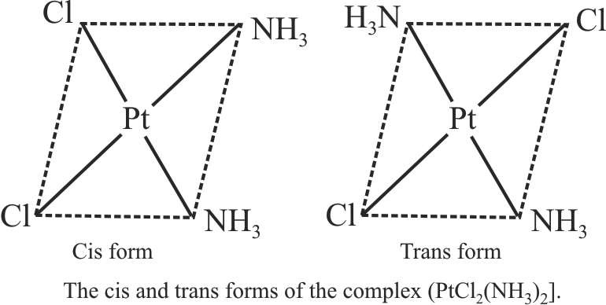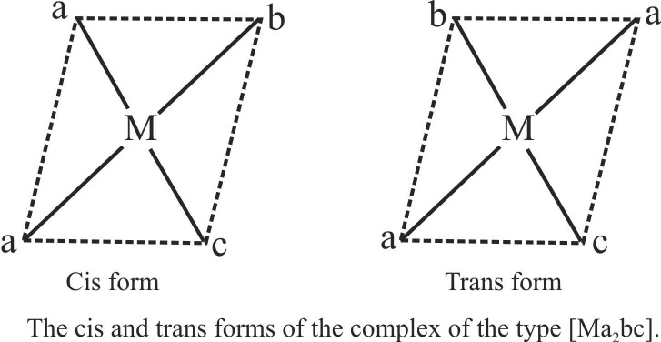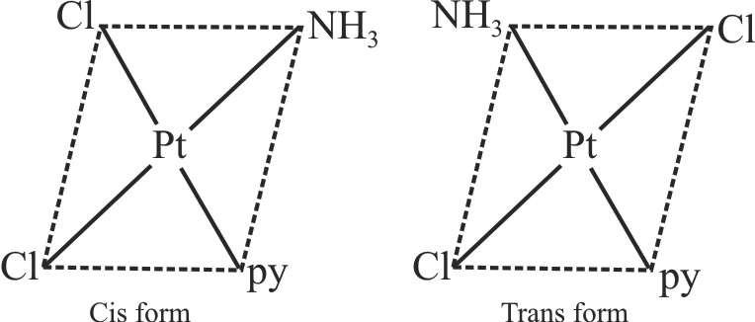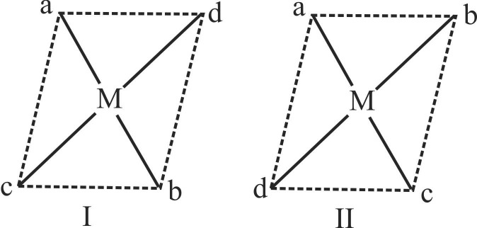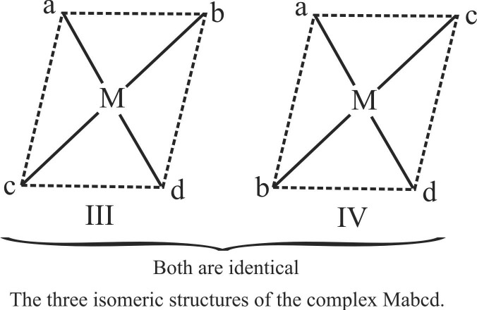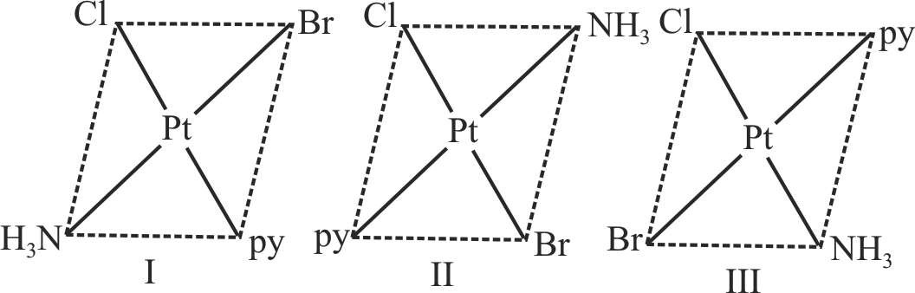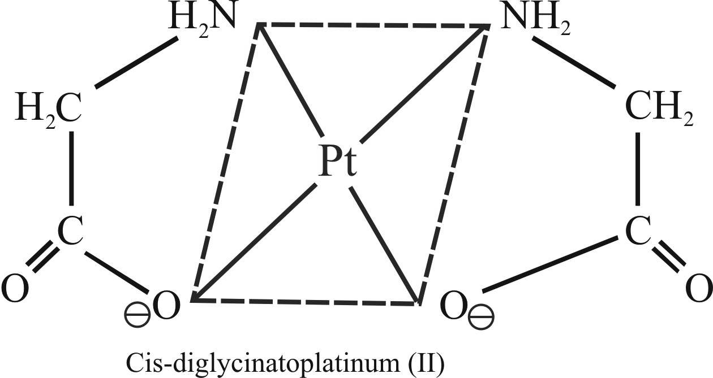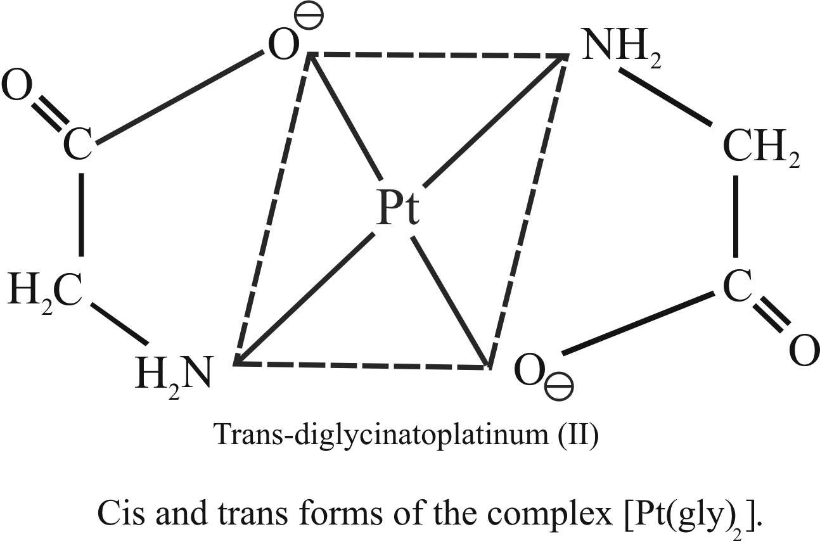

Example - 2

Draw the geometrical isomers of [PtCl2(NH3)py]

Sol.

+919814516618

* + - 1. Geomertical Isomerism in octahedral complexes

1. Ma4b2

Example - 7

Draw the geometrical isomers of [Cr(gly)3]

Example - 5

Draw the geometrical isomers of [CrCl (NH ) ]+

2 3 4

Sol.

RAKESH KUMAR

Lecturer in Chemistry

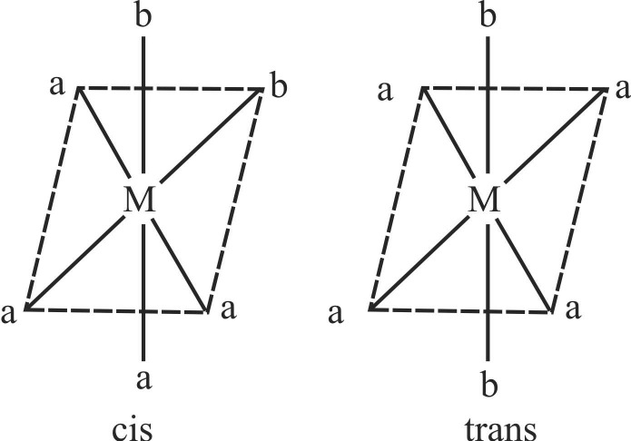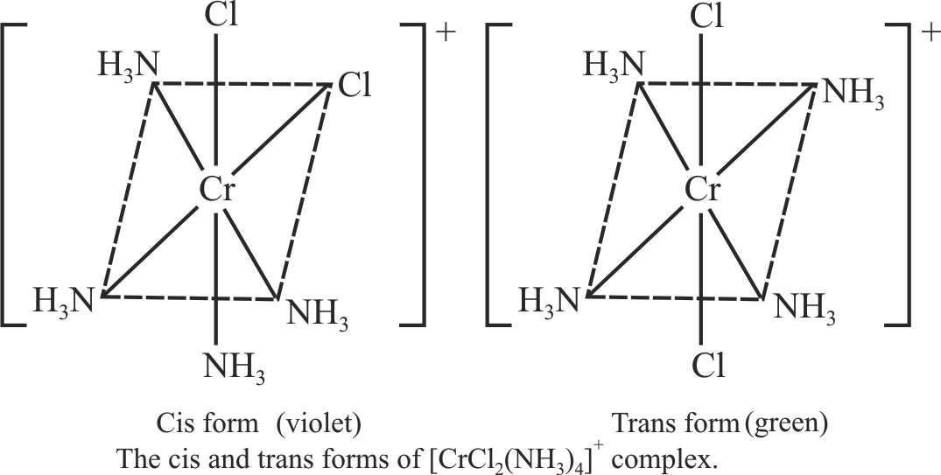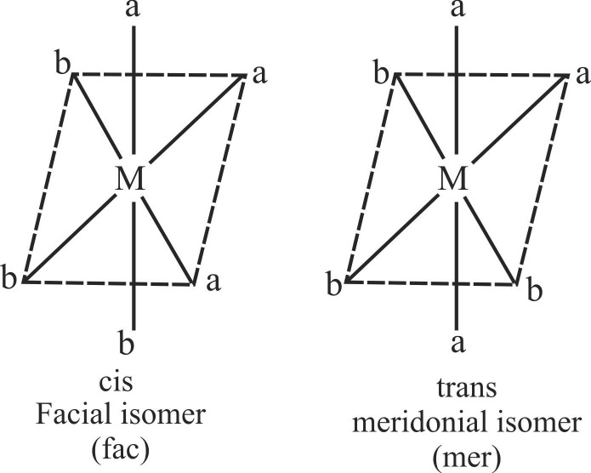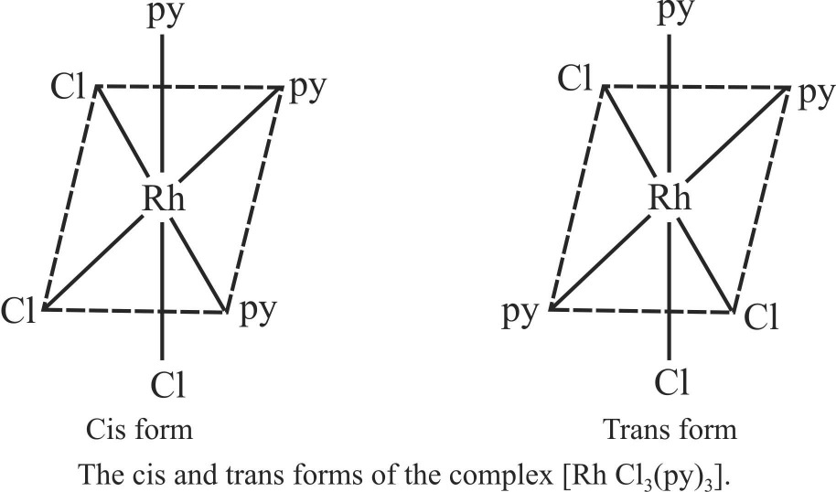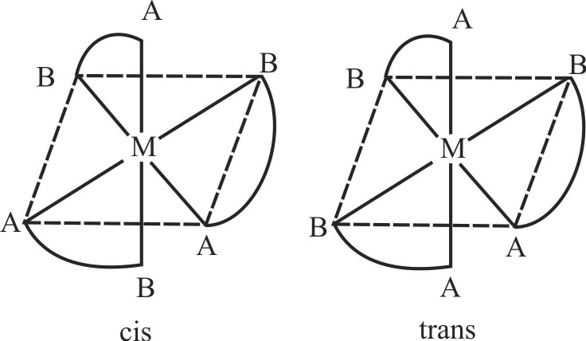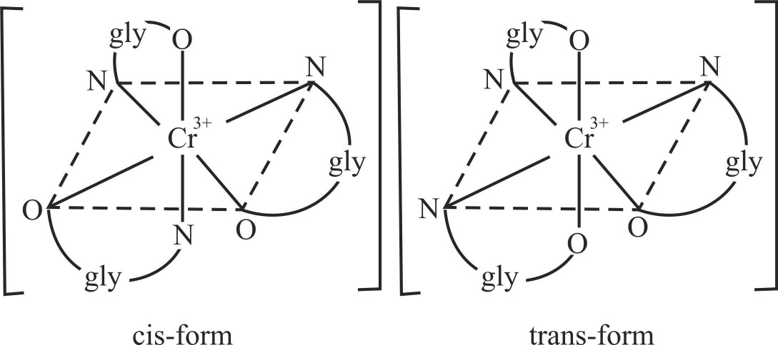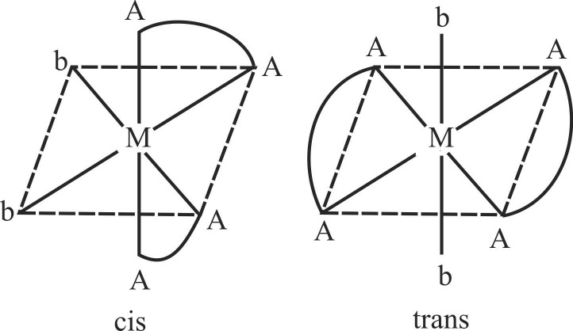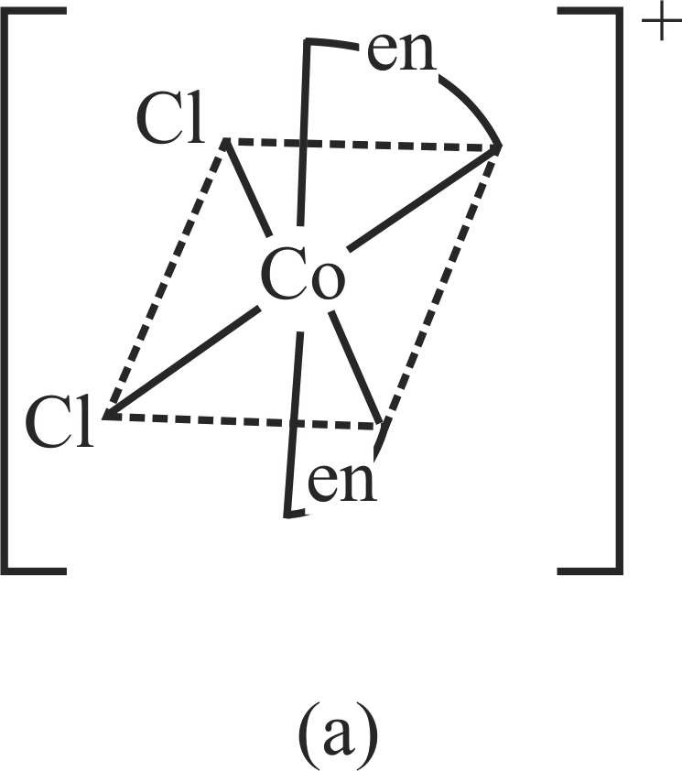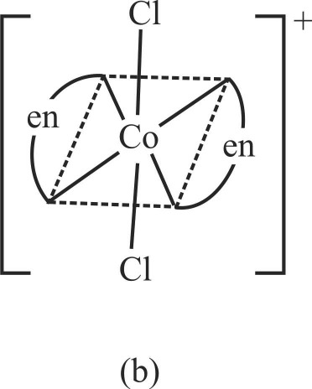

Sol.

5. M(AA)2b2

1. Ma3b3

Example - 8

Draw the geometrical isomers of [CoCl (en) ]+

2 2

Sol.

Example - 6

Draw the geometrical isomers of [RhCl3(py)3]

Sol.

Cis and trans-isomers of [CoIII (en) Cl ]+ ion.

2 2

* 1. Cis-isomer (b) trans-isomer

1. Mabcdef : They form 15 isomers
2. M (AB)3

+919814516618

6. M (AA)2bc

Example - 9

Draw the geometrical isomers of [CoIII (en ) (NH ) (Cl)]2+

2 3

Sol.

8. Ma2b2c2

Example - 11

Draw the geometrical isomers of [PtCl2Br2(NH3)2]

Cis and trans-isomers [CoIII (en ) (NH ) (Cl)]2+ ion

2 3

7. M(AA)a2b2

Sol.

Example - 10

Draw the geometrical isomers of [CoIII (en) (NH ) Cl ]+

3 2 2

Optical Isomerism in octahedral complexes

1. Mabcdef

Example - 12

Draw the optical isomers of [Pt(Cl)(Br)(I)(py)(NO2)(NH3)]

Sol.

Sol.

cis and trans-isomers of [CoIII (en) (NH ) Cl ]+

3 2 2

Optical d and 1-forms [PtIV (py) (NH ) (NO ) (Cl) (Br) (I)]0

3 2

RAKESH KUMAR

Lecturer in Chemistry

+919814516618

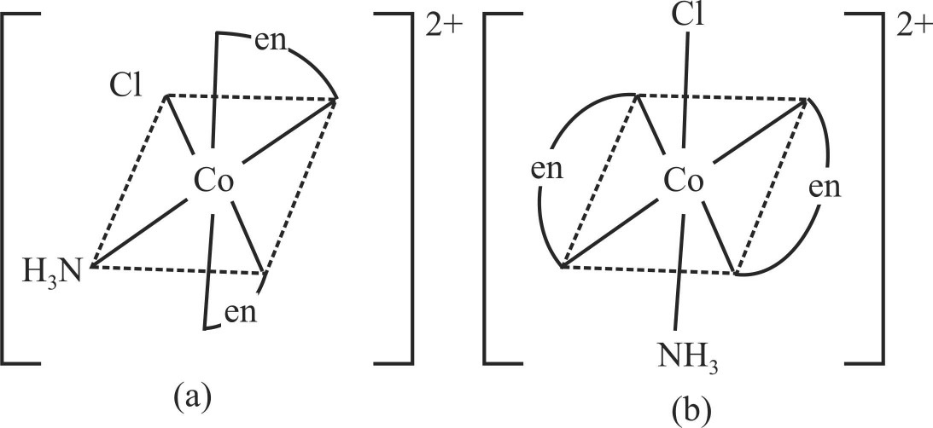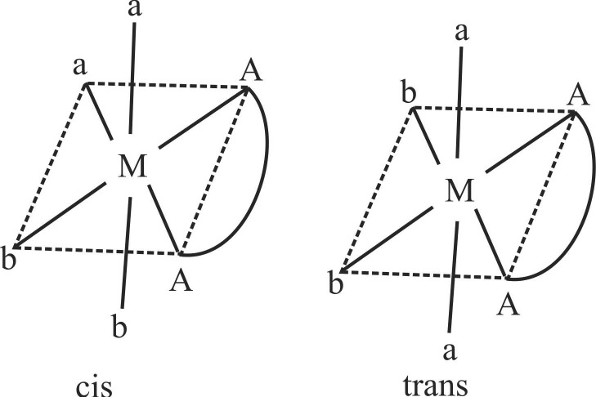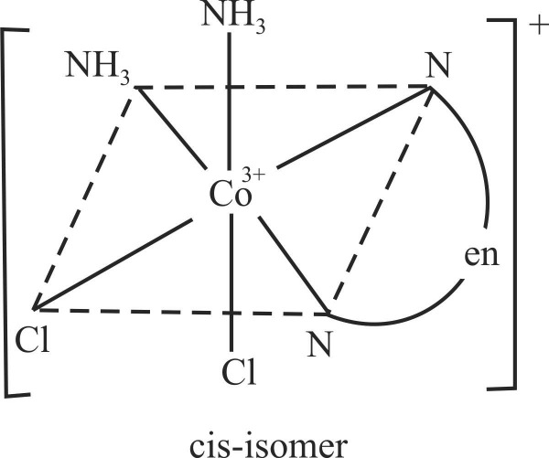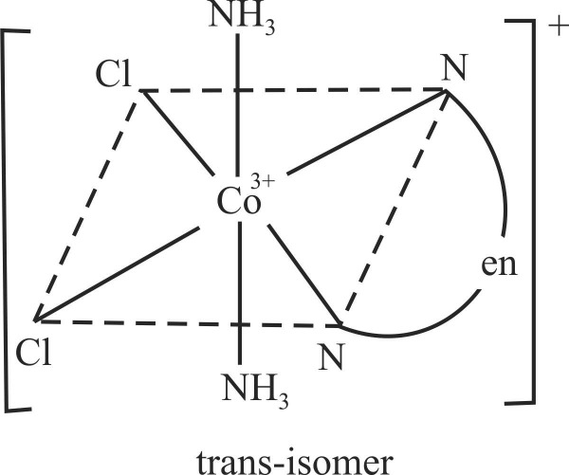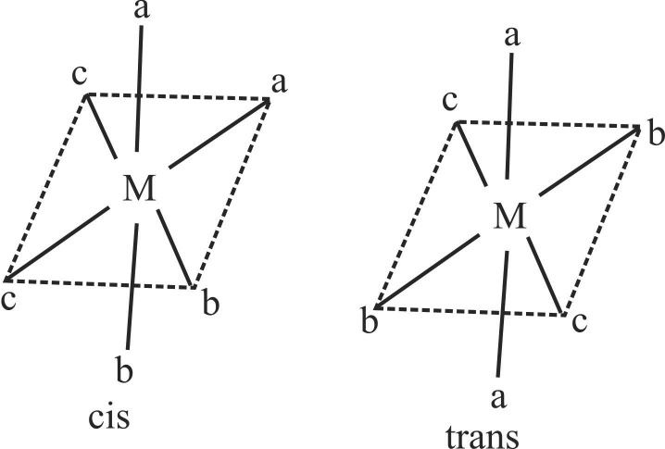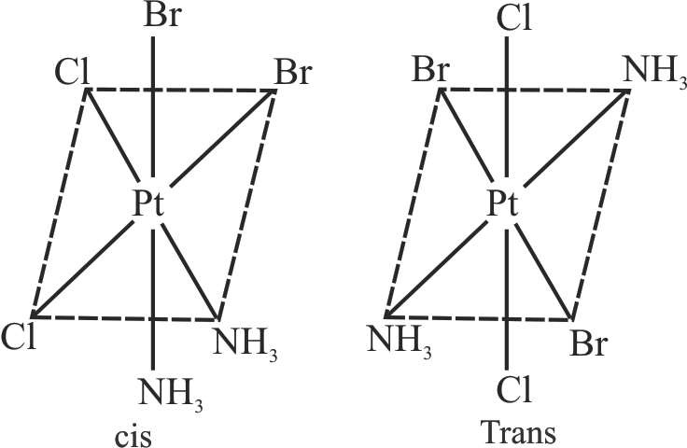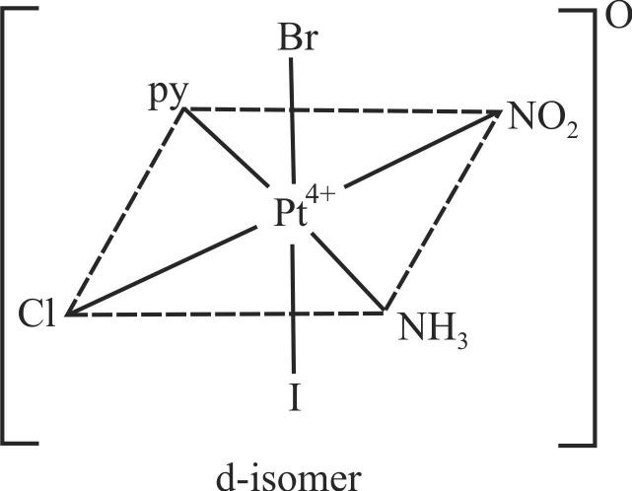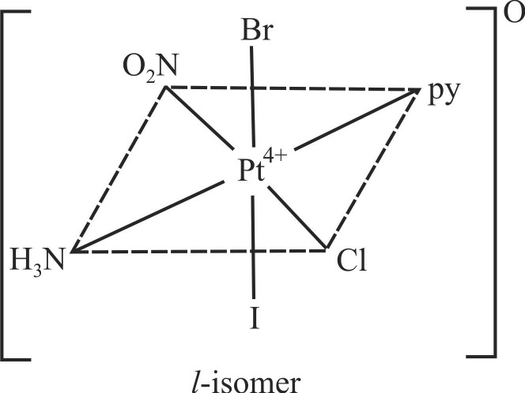

1. M (AA)3

Example - 13

Draw the optical isomers of [Co(en) ]3+

3

Sol.

5. cis Ma2b2c2

The two optical isomeric forms of the complex [Co(en) ]3+

3

3. M (AB)3

Example - 16

Draw the optical isomers of [PtCl2Br2(NH3)2]

Sol.

Example - 14

Draw the optical isomers of [Cr(gly)3]

6. cis M(AA)b2c2

 Example - 17

Draw the optical isomers of [CoCl (en) (NH ) ]+

Sol.

Sol.

2 3 2

4. cis M (AA)2b2

Example - 15

Draw the optical isomers of RhCl (en) ]+

2 2

Sol.

7. cis M(AA)2bc

Example - 18

Draw the optical isomers of [CoCl (en) Br]2+

RAKESH KUMAR

Lecturer in Chemistry

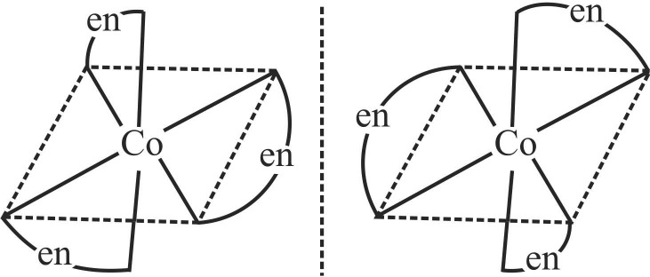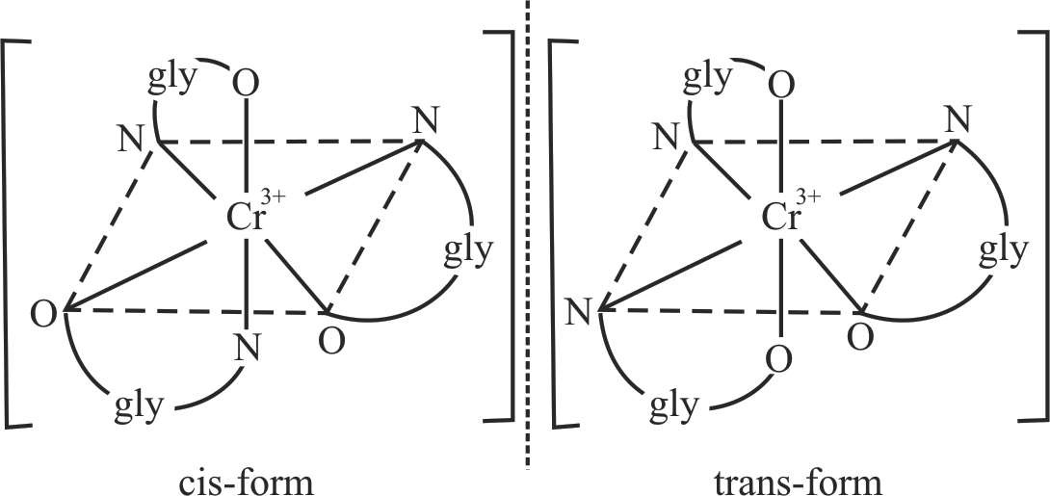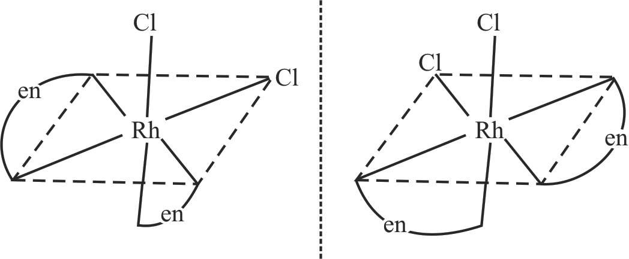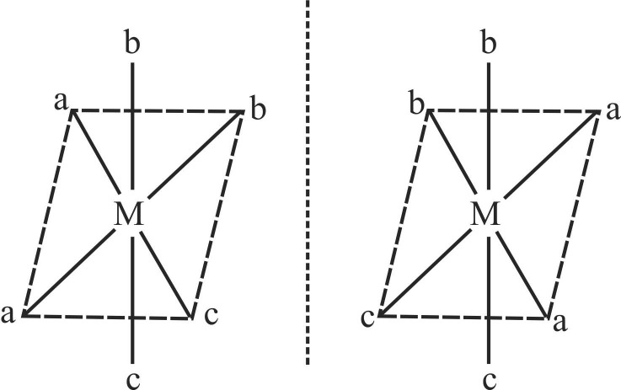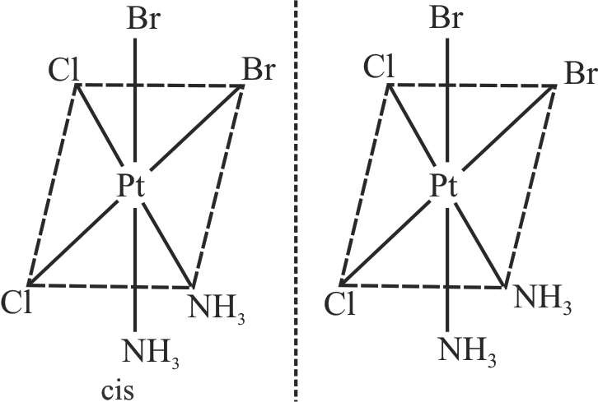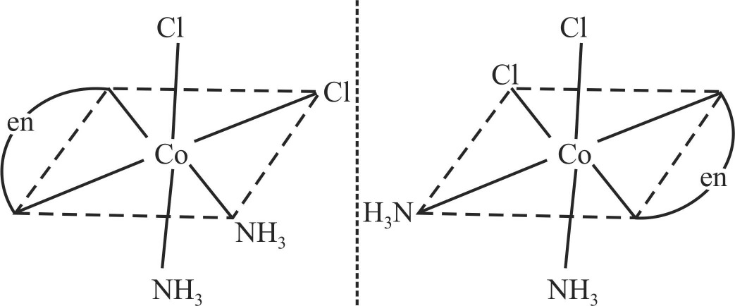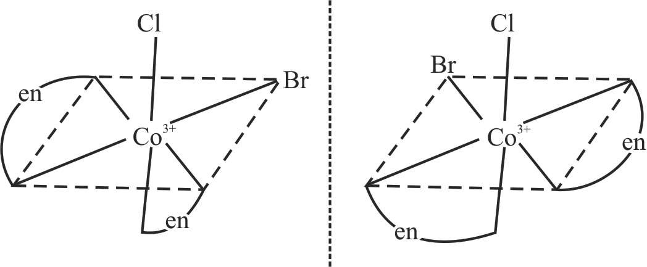

2

Optical active isomers of cis [RhCl2(en)2]+

+919814516618

# 11. STABILITY OF COORDINATION COMPOUNDS

The stability of a complex in solution refers to the degree of association between the two species involved in the state of equilibrium.

If we have a reaction of the type :

M + 4L v— **—**~— ML

4

then the larger the stability constant, the higher the proportion of ML4 that exists in solution. Free metal ions rarely exist in the solution so that M will usually be surrounded by solvent molecules which will compete with the ligand molecules, L, and be successively replaced by them. For simplicity, we generally ignore these solvent molecules and write four stability constants as follows :

(b) Volumetric analysis : Hardness of water can be estimated by titration with EDTA. The metal ions causing hardness, that is Ca2+ and Mg2+, form stable complexes with EDTA.

1. Metal extraction and purification : Extraction of metals, such as silver and gold, is carried out by forming their water soluble cyanide complexes with the ore. Pure gold can then be obtained from the solution by addition of zinc. Similarly, metals can be purified by formation and then decomposition of their coordination compounds. For example, impure nickel obtained after extraction may be converted into pure nickel by first converting it to nickel carbonyl and then decomposing.
2. Catalysis : Coordination compounds are used as catalysts in important commercial processes. For example,
3. The Zeigler-Natta catalyst (TiCl4 and trialkyl aluminium) is

M + L

ML + L

ML2 + L

ML3 + L

v— **—**~— ML K1 = [ML]/[M][L]

v— **—**~— ML2 K2 = [ML2]/[ML][L]

v— **—**~— ML3 K3 = [ML3]/[ML2][L]

v— **—**~— ML4 K4 = [ML4]/[ML3][L]

used as a catalyst in the formation of polyethene.

1. The Wilkinson catalyst - RhCl(PPh3)3 is used in the hydrogenation of alkenes.
2. In the Monsanto acetic acid process, various rhodium complexes, such as [Rh(CO)2I2], [Rh(Cl)(CO)(PPh3)2] or [Rh(Cl)(CO)2]2, are used as catalyst in the presence of CH3I,

I2 or HI as activator.

where K1, K2, etc., are referred to as stepwise stability constants. Alternatively, we can write the overall stability constant thus :

1. Electroplating : Coordination compounds of gold, silver and copper are used as components in the baths used for electroplating articles of other metals with these metals. For

example, in silver plating, K[Ag(CN)2] is used as an

M + 4L

v— **—**~— ML

þ = [ML ]/[M][L]4

electrolyte; in gold plating, K[Au(CN) ] is used as an

4 4 4 2

The stepwise and overall stability constant are therefore related as follows :

þ4 = K1 × K2 × K3 × K4 or more generally,

þ = K × K × K × K K

n 1 2 3 4 n

The instability constant or the dissociation constant of coordination compounds is defined as the reciprocal of the

electrolyte; and in copper plating, K3[Cu(CN)4] is used as an electrolyte.

1. Biological importance : Some important biological compounds are coordination complexes. For example, chlorophyll is a complex of Mg2+. This green pigment plays a vital role in photosynthesis in plants. Similarly, haemoglobin, the red pigment present in blood, is a

formation constant.

12. IMPORTANCE AND APPLICATIONS OF COORDINATION COMPOUNDS

coordination complex of Fe2+ and vitamin B nutrient, is a complex compound of Co3+.

12, an essential

1. Analytical chemistry : The analytical applications of coordination chemistry are in

(a) Qualitative and quantitative analysis : Metals ions form colored coordination compounds on reaction with a number of ligands. These reactions are used for detection of the metal ions. The colored complexes formed can be used for the estimation of metals by classical or instrumental methods such as gravimetry or colorimetry. Some examples are given as follows :

The presence of iron ions (Fe3+) can be detected by the addition potassium ferrocyanide solution, which results in formation of Prussian blue complex.

Fe2+ + K Fe(CN) → KFe[Fe(CN) ] + 2K+

+919814516618

3 6 6

6. Medicinal uses : Complexing or chelating agents are used in treating metal poisoning, wherein, the coordination complex is formed between toxic metal in excess metal and the complexing agent. For example, EDTA is used in lead poisoning. EDTA, when injected intravenously into the bloodstream, traps lead forming a compound that is flushed out of the body with the urine. Other heavy metal poisonings that can be treated similarly with chelation therapy are mercury, arsenic, aluminium, chromium, cobalt, manganese, nickel, selenium, zinc, tin and thallium. Similarly, chelating ligands D-penicillamine and desferrioxime B are used for removal of excess copper and iron, respectively. New potent

drugs are being created using various derivatives of metallocene. A platinum complex [PtCl2(NH)32] called cis- platin is used in treatment of cancer.

RAKESH KUMAR

Lecturer in Chemistry

1. Co-ordination compounds are the compounds in which the central metal atom is linked to a number of ligands (ions or neutral molecules) by co-ordinate bonds i.e. by donation of lone pairs of electrons by these ligands to the central metal atom ion.

13. CO-ORDINATION COMPOUNDS AND COMPLEX IONS

If a such a compound carries positive or negative charge, it is called a complex ion, e.g. [Fe(CN) ]4–, [Cu(NH ) ]2+.

An atom, ion or molecule which can donate alteast a pair of electrons to the central atom to form a coordinate bond (or dative linkage) is called as a ligand or a coordinating group. Further in a ligand, the particular atom which actually donates the electron pair is called the donor atom.

The ligands act as Lewis bases as they donate one or more electron pair to the central metal atoms or ions witch act as Lewis acids by accepting electrons.

6 3 4

Hence Co-ordination compounds may also be defined as those compounds which contain complex ions, e.g.,

K4[Fe(CN)6], [Cu(NH3)4]SO4, etc. In general, a complex ion

is represented as [ML ] ± x. Where M is the metal ion, L

n

represents ligands, n is the coordination number of metal ion and x is the net charge on the complex.

1. There are four types of complexes :
2. Cation as complex ion, (carrying a net positive charge) e.g., [Cr (NH ) ]3+ in [Cr(NH ) ]Cl .

3 6 3 6 3

* + 1. Types of Ligands : Ligands can be classified on the number of lone pair electrons they donate to the central metal atom or ion.

1. Monodentate or unidentate ligands : They have one donor atom that donates only one electron pair to central metal

atom. eg : F–, Cl–, Br– , H O, NH , CN–, NO– , OH–, NH– ,

1. Anion as complex ion, (carrying a net negative charge) e.g.,

2 3 2 2

[Fe(CN) ]3– in K

6

3

[Fe(CN)6].

CO, R–OH, SCN–, , RI–C, OSOH–,

–, RS–,

1. Cation and anion both as complex ion. Carrying both +ive and –ive change. For e.g., [Pt(Py)4] [PtCl4].

(Dimethyl sulfoxide), NH2

NH2

NO– ,

2

1. Neutral complex (A complex carrying no net charge) e.g., [Ni(CO)4] etc.

14. TERMINOLOGY OF CO-ORDINATION COMPOUNDS

(Central atom/ion or Acceptor atom/ion) :

The cation or neutral atom to which one or more ligands (neutral molecules or anions) are attached or coordinated is the centre of coordination.

The central atom/ion must have empty orbitals as it acts as an acceptor and thus has to accommodate electron pairs donated by the donor atom of the ligand. This explains why the transition metal having empty d-orbitals, form coordination compounds very readily.

For example in the complexes [Ni(NH ) ]2+ and [(CN) ]3–,

NO– , S2–, O2– , pyridine.

1. Bidentate ligands : Ligands which have two donor atoms and have the ability to link with central metal at two positions are called bidentate ligands

3

Example

(1) (2)

(3) (4)

3 6 6

RAKESH KUMAR

Lecturer in Chemistry

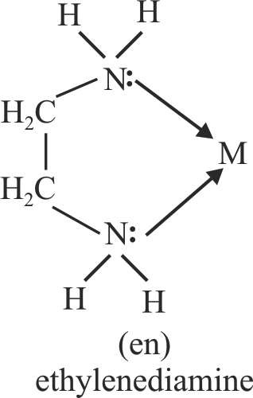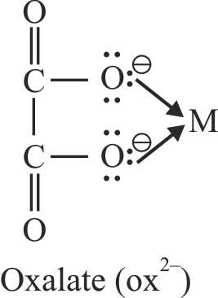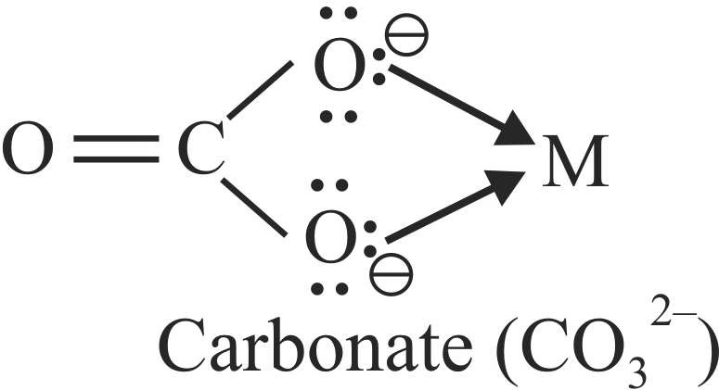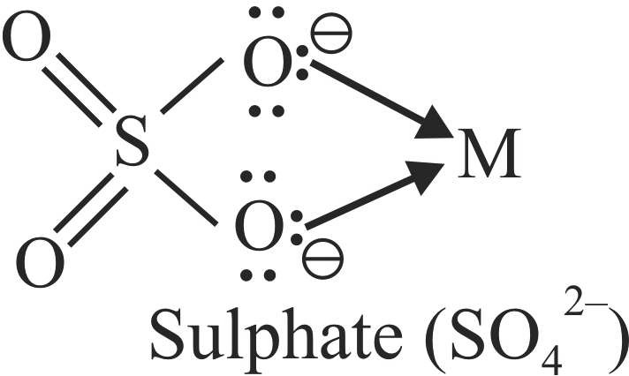

14.1 Centre of Corrdination

14.2 Ligands

Example

Ni2+ and Fe3+ respectively are the central ions.

+919814516618

* 1. Pentadentate ligands

They have five donor atoms

(5) (6)

(7) (8)

* 1. Hexadentate Ligands

They have six donor atoms.

(9) (10)

1. Tridentate Ligand

The ligands having three donor atoms are called tridentate ligands.

1. Tetradentate ligand

These ligand possess four donor atoms

* + 1. Chelating ligands :

A bidentate or a polydentate ligand is known as a chelating ligand if on co-ordination it results in the formation of a cyclic ring structure. The complex thus formed are called chelates.

RAKESH KUMAR

Lecturer in Chemistry

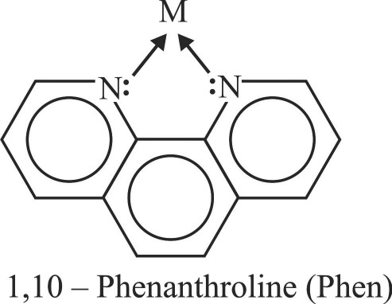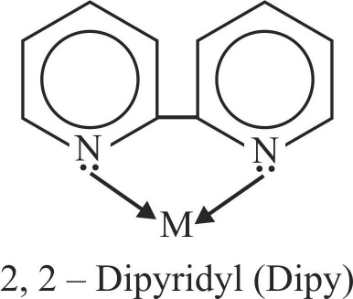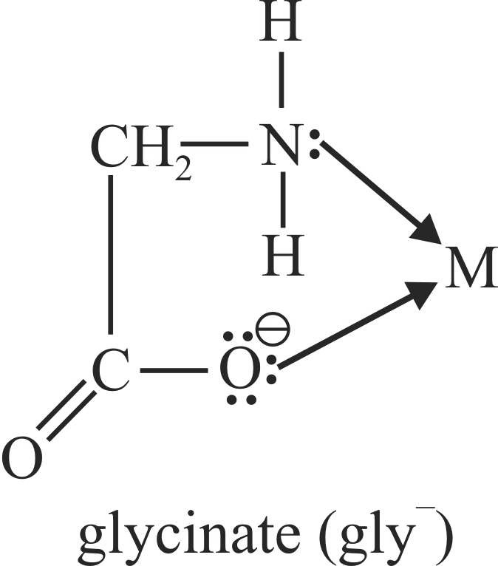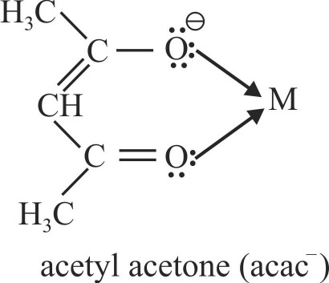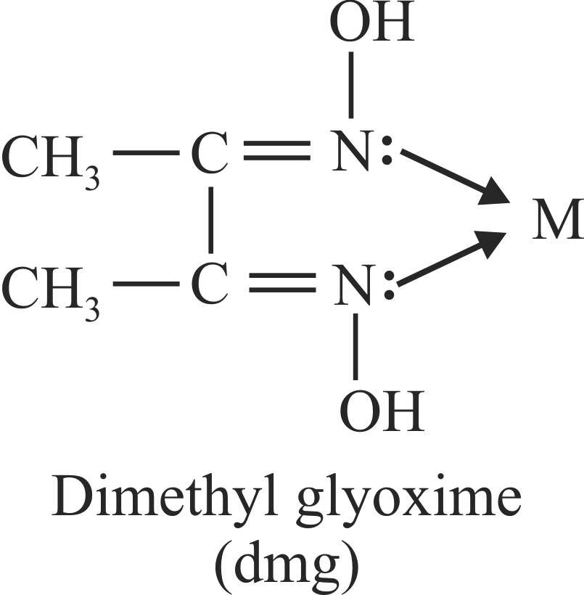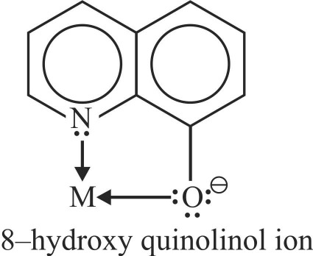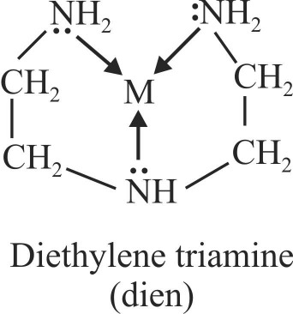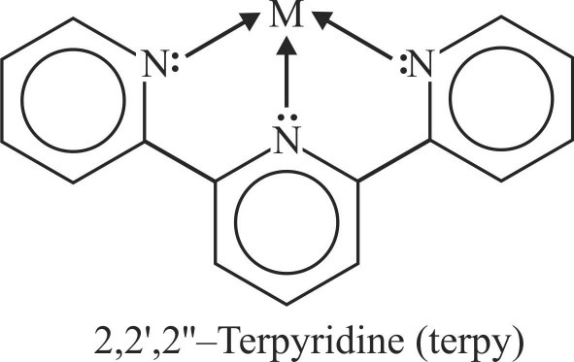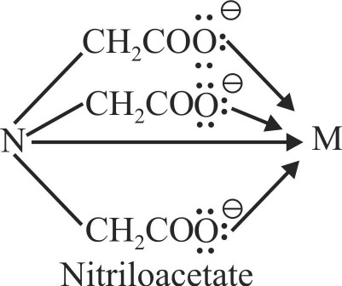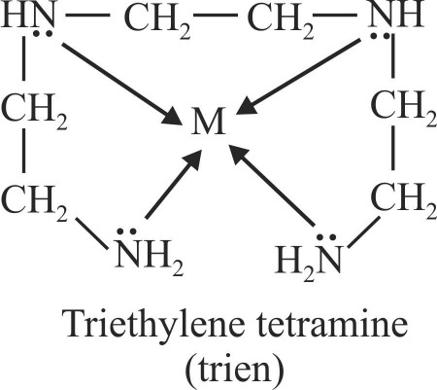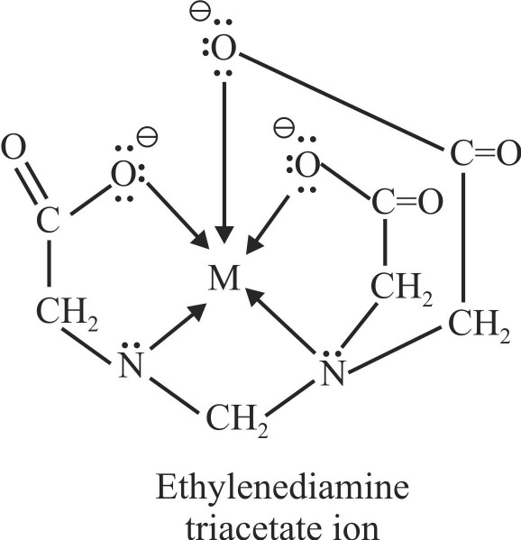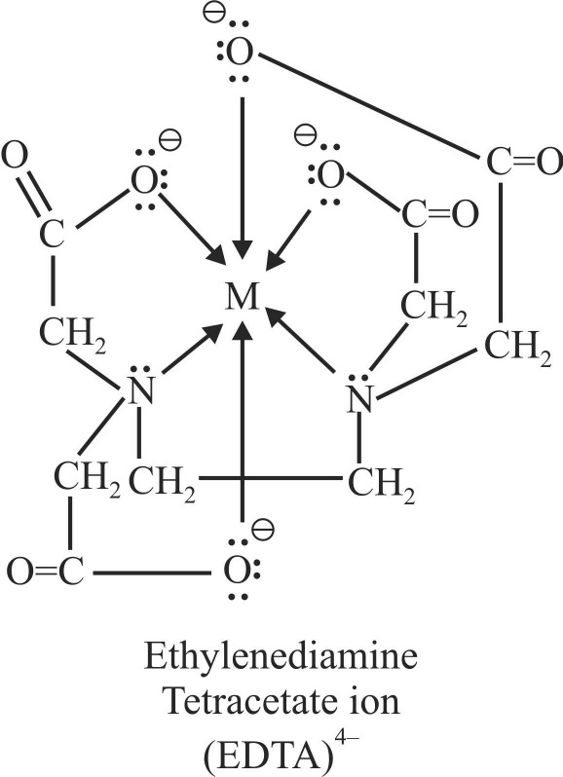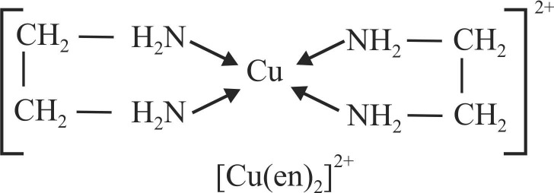

(2)

(1)

Example :

(2)

(1)

Example :

Example :

Example :

The chelates containing 5 or 6 membered rings are more stable. Ligands with larger groups form more unstable rings than with smaller groups due to steric hinderance.

+919814516618

* + 1. Ambidentate ligands :

The ligands which have two donor atoms but in forming complexes only one donor atom is attached to the metal atom at a given time. Such ligands are called ambidentate ligands.

16.1 In general, higher the charge density on the central ion, the greater is the stability of its complexes, i.e., the higher value

16. STABILITY OF COORDINATION COMPOUNDS IN SOLUTIONS

of charge , the greater is the stability of its

radius of the ion

complexes. Electronegativity of the central ion influences the stability. The higher the electronegativity of the central ion, the greater is the stability of its complexes.

16.2. The higher the oxidation state of the metal, the more stable is the complex. The charge density of Co3+ ion is more than Co2+ ion and thus, [Co (NH ) ]3+ is more stable than [Co

3 6

(NH ) ]2+. Similarly, [Fe (CN) ]3– is more stable than [Fe

# 15. CO-ORDINATION NUMBER (C.N)

The number of atoms of the ligands that directly bound to the central metal atom or ion by co-ordinate bonds is known as the co-ordination number of the metal atom or ion. It is also equal to the secondary valency.

3 6 6

(CN) ]4–.

6

The cyano and ammine complexes are far more stable than those formed by halide ions. This is due to the fact that NH3

and CN– are strong Lewis bases.

The complexes of bivalent cations (M2+) of 3d-series shown the following order of stability :

Cation Mn2+ Fe2+ Co2+ Ni2+ Cu2+

Ionic size 0.91 0.83 0.82 0.78 0.69 decreases Stability of increases

the complex (Irving William order)

Chelating ligands form more stable complexes as compared to monodentate ligands. Greater is the chelation, more is the stability of complex.

RAKESH KUMAR

Lecturer in Chemistry

+919814516618

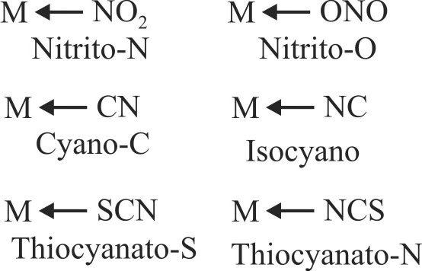

Example :

6

2

6

[Ag (CN) ]–

2

[Pt (NH3)2 Cl2]

[Ca (EDTA)]2–

K [Fe (CN)6]

Co-ordination numbers

Complex